 

Project Initialization and Planning Phase

|  |  |
| --- | --- |
| Date | 15 October 2024 |
| Team ID | 740663 |
| Project Name | Predicting Diamond Prices With ANN Using  DeepLearning |
| Maximum Marks | 3 Marks |

**Define Problem Statements (Customer Problem Statement Template):**

In the diamond industry, accurately determining the price of a diamond is critical for buyers, sellers, appraisers. Diamond prices are influenced by multiple factors, including the 4Cs: **Carat**, **Cut**,

**Colour**,and **Clarity**, as well as other attributes like **dimensions** and **fluorescence**. Pricing

inconsistencies can lead to mistrust in the market, revenue loss, and customer dissatisfaction.

The goal is to develop a machine learning model to accurately predict diamond prices based on features like **carat**, **cut**, **colour**, **clarity**, and **dimensions**. This will help buyers and sellers ensure fair pricing,

improve market transparency, and automate valuation processes.

**Example:**

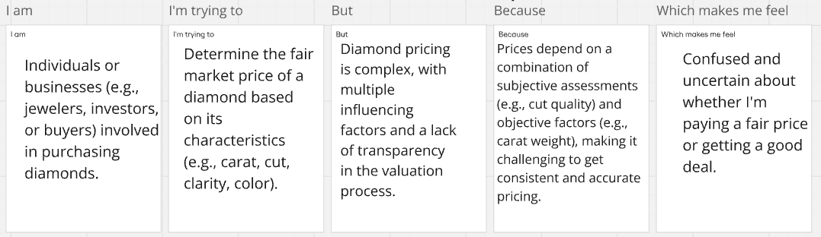

|  |  |  |  |  |  |
| --- | --- | --- | --- | --- | --- |
| **Problem Statement (PS)** | **I am (Customer)** | **I’m trying to** | **But** | **Because** | **Which makes me feel** |
| PS-1 | Individuals or  businesses (e.g., jewelers,  investors, or buyers)  involved in | Determine the fair market  price of a diamond  based on its characteristics (e.g., carat, cut, clarity, color). | Diamond pricing is complex, with  multiple  influencing factors and a lack of  transparency in the | Prices  depend on a combination of  subjective assessments making it  challenging to get consistent  and | Confused and uncertain  about whether I'm paying a  fair price or getting a good deal. |

|  |  |  |  |  |  |
| --- | --- | --- | --- | --- | --- |
|  | purchasing diamonds. |  | valuation process. | accurate pricing. |  |
| PS-2 | Retailers or e-commerce platforms  selling diamonds to end  customers. | Offer  competitive and  transparent pricing for diamonds to attract and  retain  customers. | The pricing process is highly  variable and depends on many  factors that are hard to standardize. | There’s no universally accepted  tool or model to  accurately predict diamond prices  based on all relevant attributes. | Frustrated and at risk of losing  customers due to  inconsistent or  uncompetitive pricing. |